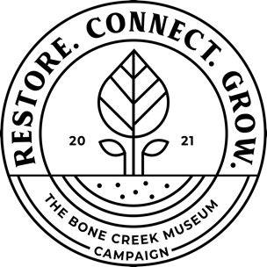
Bone Creek Art Museum
Engraved Tribute Brick Order Form

Bone Creek Museum of Agrarian Art is selling Tribute Bricks as part of our campaign to expand into the Ford Building. These tributes will be made a permanent portion of the new museum. Bricks are $200 each.
Buyer’s Name:
Buyer’s Phone Number:
Buyer’s Email Address:
Buyer’s Address:
Fill out the template below with the text you would like printed on the brick. No more than 16 characters per line, each brick is 4”x8” and will have two lines. Spaces count as characters and there must be a space between each word. Please print carefully.

Paid:

Check

Cash

Card
Checks payable to:
Bone Creek Art Museum
575 E Street
David City, NE 68632

